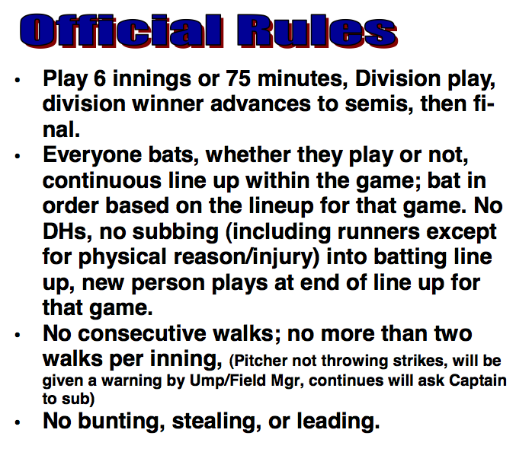

**Rules Continued**………………...

* **Slow Pitch with 6-10’ arch**
* **Forfeit after 15 minutes if team not ready to play.**
* **Two homeruns per inning; Homerun after two will become a single.**
* **A total of 10 players per field.**
* **Score and strike zones will include both the orange plate extension mat and plate.**
* **Leaving base early before batter makes contact is an out. One warning per game.**
* **Foul ball on 3rd strike is an out.**
* **No metal cleats, will not play.**
* **Confirm score after each inning with opposing team.**
* **Tie Break for division play: 1. Head to head, 2.Run differential, (7 runs max. per game), 3. Fewest runs allowed, 4. Coin toss.**
* **Use ONLY wooden bats for the Men’s games**